H.T No
Regulations:
A22

Sreenidhi Institute of Science and Technology
(An Autonomous Institution)
Code No:9BC01 Date: 12-September-2024 (AN)

B.Tech I-Year I- Semester External Examination, September-2024 (Supplementary)
ENGINEERING GRAPHICS (CIVIL,EEE,MECH,ECE,ECM,AIML and IOT)

Time: 3 Hours Max.Marks:60

Note: a) No additional answer sheets will be provided.
b) All sub-parts of a question must be answered at one place only, otherwise it will not be valued.
c) Missing data can be assumed suitably.
Bloom's Cognitive Levels of Learning (BCLL)

Remember | L1 | Apply | L3 | Evaluate | L5
Understand | L2 | Analyze | L4 | Create | L6

Part - A Max.Marks: 6x2=12

Answer all QUESTIONS, EACH QUESTION CARRIES 2 MARKS.

 |  | BCLL | CO(s) | Marks
1 | What do you mean by the term conic section | L1 | CO1 | [2M]
2 | Show the graphical representation of First angle Projection and Third angle Projection | L2 | CO2 | [2M]
3 | Construct a pentagon of side 30mm | L2 | CO3 | [2M]
4 | What is a Pyramid | L1 | CO4 | [2M]
5 | What is isometric view | L1 | CO5 | [2M]
6 | What are the advantages of CAD | L1 | CO6 | [2M]

Part – B Max.Marks: 6x8=48
ANSWER ALL QUESTIONS. EACH QUESTION CARRIES 8 MARKS.

 |  | BCLL | CO(s) | Marks
7. | A circle of 40 mm diameter rolls on a horizontal line for one revolution name the curve. Also draw tangent and normal to it at any point. | L3 | CO1 | [8M]
 | OR
8 | Construct a Parabola if the A fixed point is at distance of 50mm from fixed straight line trace the path of curve if eccentricity is 2/3. Also draw a tangent and normal to it at 55 mm from the directrix | L1 | CO1 | [8M]
9. | The Front view and Top view of a straight line PQ measures 50mm and 65mm respectively. the point P is in the HP and 20mm in front of VP, and the front view of the line is inclined at 45 º to XY. Determine the true length and true angle | L3 | CO2 | [8M]
 | OR
10 | A line AB is 75mm long. A is 50mm in front of VP and 15 above HP. B is 15mm in front of VP and is above HP. The TOP view of AB is 50mm long. Draw and measure the Front view. Find true inclinations. | L3 | CO2 | [8M]
11. | A Circular Plane of diameter 50mm is inclined to HP at 30° and its Draw its Projections. | L3 | CO3 | [8M]
 | OR
12 | A Hexagonal Pyramid of side 30mm axis length 70mm has its axis inclined to VP at 45° Draw its projections. | L3 | CO3 | [8M]
13. | Draw the development of a cone of diameter 40mm axis length 65mm is sectioned by a plane inclined at 35° to HP and passing through midpoint of the axis of the cone. | L4 | CO4 | [8M]
 | OR
14 | A Pentagonal Pyramid of side 30mm axis length 70mm has its base resting on HP such that its rectangular face is parallel to VP .It is cut by a plane inclined at 45⁰ to the H.P bisecting the axis. Draw the development | L4 | CO4 | [8M]
15. | Draw the isometric view of a cylinder of base diameter 50mm axis length 60 mm | L4 | CO5 | [8M]
 | OR
16 | Draw the isometric view for the following figure  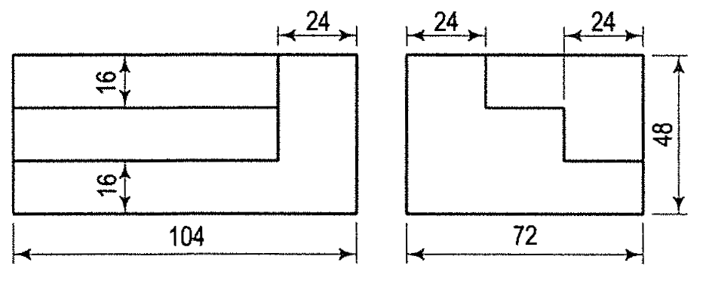 | L4 | CO5 | [8M]
17. | Draw the Front view Top view and side view for the following figure  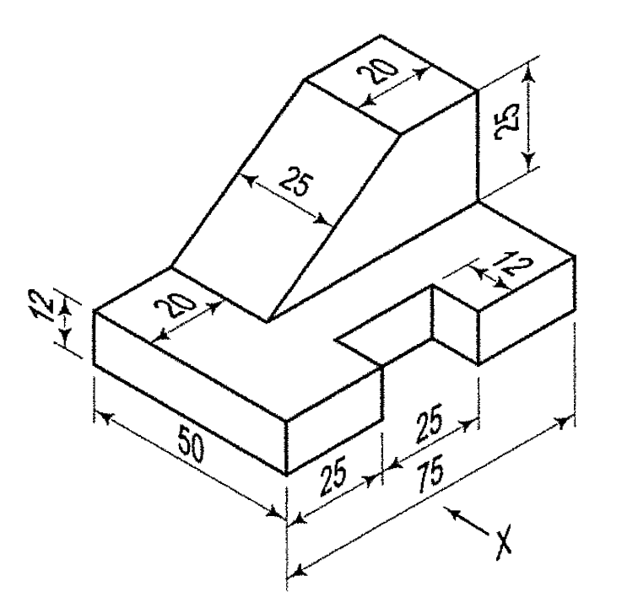 | L4 | CO6 | [8M]
 | OR
18 | Draw the Front view Top view and side view for the following figure  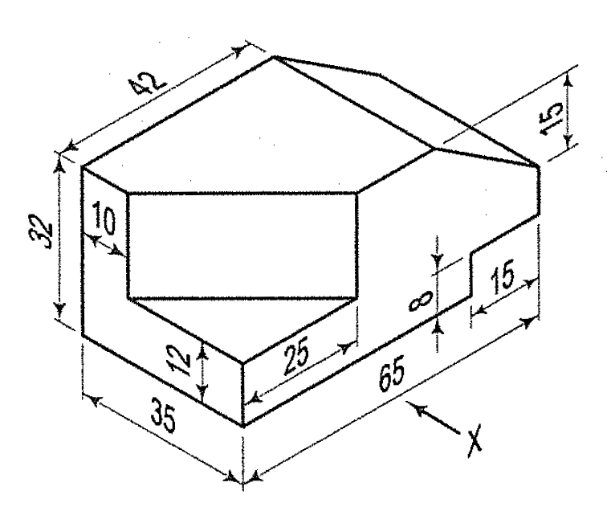 | L4 | CO6 | [8M]

-- 00 -- 00 –

